Alisher Siddikov

**Assignment 1 (200 points)**

The first question can be as a single or separate document (PDF, Word, etc.) files. The second question should be solved in Excel. Each question is worth 100 points.

***Note, in addition to points being taken off for accuracy, points may also be taken off for lack of organization and failure to use Excel formulas and appropriate Cell referencing/addressing within the spreadsheets.***

**Instructions:**

**1. Formulation (Do Not Need To Solve):**

SteelCo manufactures three types of steel at two different steel mills. During a given month, Mill 1 has 200 hours of blast furnace time available, whereas Mill 2 has 300 hours. Because of differences in the furnaces at each mill, the time and cost to produce a ton of steel differs for each mill and are shown in the following table. Each month, SteelCo must manufacture a total of at least 400 tons of Steel 1, 500 tons of Steel 2, and 300 tons of Steel 3 to meet demand; however, the total amount of Steel 2 manufactured should not exceed the combined amount of Steel 1 and Steel 3. Also, in order to maintain a roughly uniform usage of the two mills, management’s policy is that the percentage of available blast furnace capacity (time) used at each mill should be the same. Clearly formulate a linear program (LP) to minimize the cost of manufacturing the desired steel (you do not need to solve in Excel).

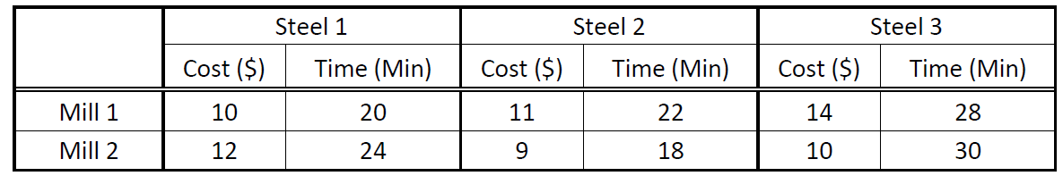

Decision variables:

xij = steel type i (i = 1, 2, 3) produced at mill j (j = 1, 2)

Objective:

Minimize Cost($) = 10x11 + 11x21 + 14x31 + 12x12 + 9x22 + 10x32

Constraints:

Subject To

20x11 + 22x21 + 28x31 <= 200*60

24x12 + 18x22 + 30x32 <= 300*60

X11 + X12 >= 400

X21 + X22 >= 500

X31 + X32 >= 300

(X11 + X12)+ (X31 + X32)>= X21 + X22